

ARDUINO DISTANCE MEASUREMENT

|  |  |
| --- | --- |
| Name: | Muhammad ‘AtiqulHakim Bin Mohd Ramli |
| Student ID: | DE96562 |
| Submission Date: | 18 December 2020 |
| Assignment: | Final Class Project |
| Subject Code: | EEED253 |
| Academic Year: | Semester 1 2020/2021 |
| Course Instructor: | Dickson Neoh Tze How (dickson@uniten.edu.my) |

Table of Contents

**Chapter 1** 2

1.1 Abstract 2

**Chapter 2** 3

2.1 Introduction 3

2.2 Component 4

2.2.1 Ultrasonic Distance Sensor HC-SR04 4

2.2.2 Arduino UNO REV3 4

2.2.3 Liquid Crystal Display (LCD) 16 by 2 Green Version 5

2.2.4 Pushbutton 5

**Chapter 3** 6

3.1 Methodology 6

3.2 Flowchart 10

3.3 Program Code 11

3.4 List of all component 11

3.5 Circuit Diagram 12

**Chapter 4** 13

4.1 Results and Discussions 13

4.1.1 Result 13

4.1.2 Discussion 16

**Chapter 5** 18

5.1 Conclusion 18

References 19

# **Chapter 1**

## 1.1 Abstract

This project is designed a device to economic or small sector that want to measure items or for ensure the social distancing between person correctly. This project also to solve a many of complain from owner market that say was very hard to check social distancing between customer to another customer. To solve both of problems, I have used a common tool which is Arduino UNO as main component With using ultrasonic sensor and Arduino UNO board will make smoothly to look the distance and also can minimize the parallax which means measurement error when reads a scale form the wrong position. To get distance calculation with correct it can be solve only using the right formula. This measurement technique provides an effective means of accurately measuring small distances. This device proposes the idea of fast and efficient counting the distance without any measurement tools.

# **Chapter 2**

## 2.1 Introduction

Today's global economy offers various adventures in every sector. In each sector, small requirements are essential for the development of major measures, including occurring new normal for today, required for all economic sectors to practice a social distance of at least 1 meter. By using different resources, we can modify them according to our specific needs and apply them in different areas. Measurement usually takes place through a measuring instrument in the early years. However, the digital transformation may be as strong as possible in the future [1].

Next to the older measuring tool like figure 2.1 is just having a body and tape measure. After that, the last measurement tools also like this, but the developer makes it change to the body by putting the LCD screen to read a distance as shown in figure 2.2. Otherwise, another measurement has many changes which have only the LCD display and laser function to take the distance as shown in figure 2.3.

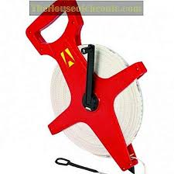

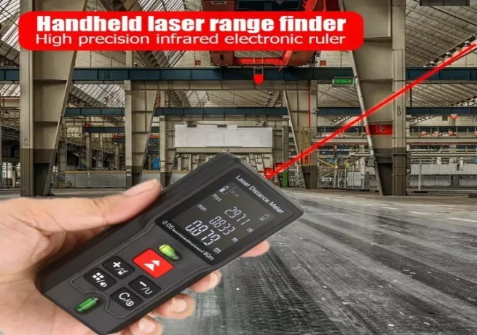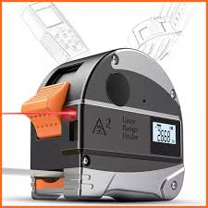

Figure 2.1 Wheel measurement Figure 2.2 Electronic measurement Figure 2.3 Laser Rangefinder

Using the Arduino UNO board, I can construct a measuring system and use a specific display unit to measure the distance, especially the centimeter (cm) and the meter (m). And then also used ultrasonic sensor HC-SR04 connected with Arduino UNO in this distance measurement device. To calculate a distance, I used an ultrasonic sensor by connecting with an Arduino UNO board because I can use the ultrasonic waves from the echo pin and trigger pin in the ultrasonic sensor and transform this sound wave to the computation of units, such as distance. This generates a 40k Hz ultrasound, which passes through the air and bounces back into the module, whether it has an object or an obstacle. I can calculate the distance based on travel time and sound velocity [2].

To produce an ultrasound for detection, the trig pin Ultrasonic board must be placed in a high condition when writing the code. It would send an 8-cycle sound pulse that will move through the sound waves and receive into the echo pin at the Ultrasonic board.

## 2.2 Component

### 2.2.1 Ultrasonic Distance Sensor HC-SR04

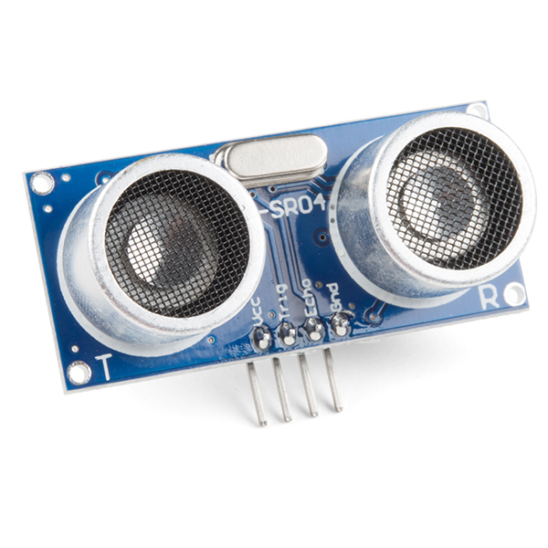

Figure 2.2.1

It produces a 40 kHz ultrasound, which is moves in the air and if there is something on the way and will return to the module. The Ultrasonic Sensor can catch up or detect from 2cm until 400cm [3]. By using Ultrasonic sensor, I can compute the distance by considering or watching the time and sound waves.

### 2.2.2 Arduino UNO REV3

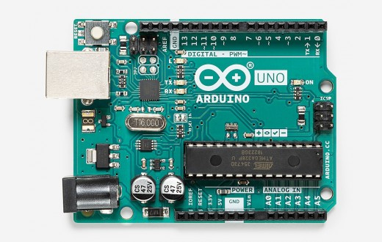

Figure 2.2.2

Arduino UNO is a unique microcontroller board because it has 14 digital I/O pins and six analog inputs, 16 MHz resonators, a USB port for computer connection, DC input, reset button.

It contains all the necessary parts to support the board, simply connect a computer using a USB cable, or can use an AC-DC adapter or a 7 – 12V battery to start an Arduino UNO [4]. I use this version of Arduino UNO REV3 because to program and send code.

### 2.2.3 Liquid Crystal Display (LCD) 16 by 2 Green Version

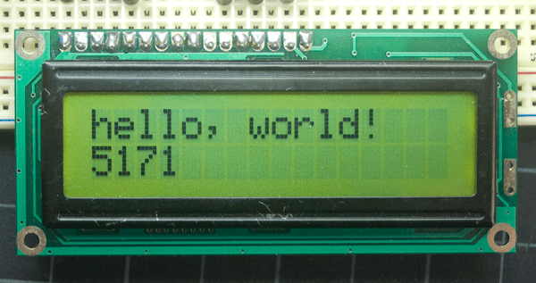

Figure 2.2.3

The Liquid Crystal Display (LCD) 16 by 2 Green Version is an electronic board display device. A Liquid Crystal Display (LCD) 16 by 2 Green Version is a basic module and is generally used in different appliances and circuits. The reasons for LCD can easily be programmed, and the characters, including personalized characters, are not limited unlike seven segments [5]. I select this LCD because to show the result of the distance I receive from the ultrasonic sensor.

### 2.2.4 Pushbutton

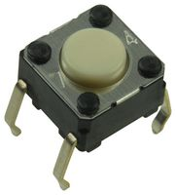

Figure 2.2.4

Pushbutton is a component that will connect between two points when I press it. There has two leg or terminal A and B. I was used this component for separate between meter value and centimeter value.

# **Chapter 3**

## 3.1 Methodology

First of all, because for the main component in this project which is Ultrasonic Sensor. I will explain how it does work in this circuit with Arduino UNO.

First, Ultrasonic Sensor has four main pins on the board which is Vcc (+5V), Trig (Input pin), Echo (Output pin), Ground (GND). Everything is very important to connect the GND and Vcc pins on the Ultrasonic board to the GND and 5-volt pins in the power pin segment on the Arduino UNO board respectively. For the Trig and Echo pins in any digital Input/Output on the Arduino board. Users must set the trig for 10 μs to a heightened level to generate the ultrasound. That is sending out 8-cycle harmonic blast that will be going to drive at the speed sound and be received in the Echo pin. The Echo pin provides the time a sound wave is traveled in microseconds. To begin, with an example, the target is 8 cm from the sensor and the sound speed is 0.034 cm/μs, then calculate the time using the formula which is the distance divide by speed and I get the answer 234.3μs. The total that I receive from the Echo pin is a double value because the ultrasonic sound wave sensor moves in the reflection that is ahead and back. Consequently, we must multiply by 0.034 the travel time obtained by the echo pin and divide it by 2 to reach the range in centimeter [2].

To construct this project is very easily and advantage if you are using the Arduino UNO equipment. For this section I will explain to you how to contrast this project:

1. 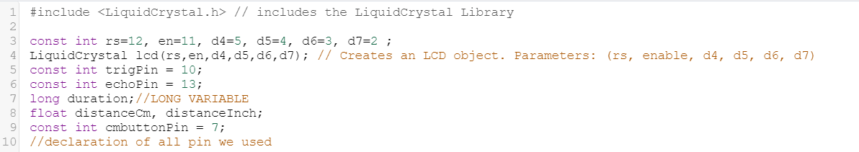

Figure 3.1

Line 1: The first thing we must do is to connect the Liquid Crystal Library by using the libraries.

Line 3-4: Declaring all pins that I was used on LCD, Ultrasonic Distance Sensor and Push button. The parameters of this object should have been the number of the Arduino Uno board Digital Input pins upon on LCD pins as follows.

Line 5-6: . By connecting pin 10 to echo and pin 13 to Trig respectively on the digital Input/Output Arduino Board as shown in figure 3.1.

Line 7: Expand a datatype for long variables but without any decimal point.

Line 8: Possibility in a measurement we have a decimal point number.

Line 9: Declare the pushbutton variable or integer.

1. 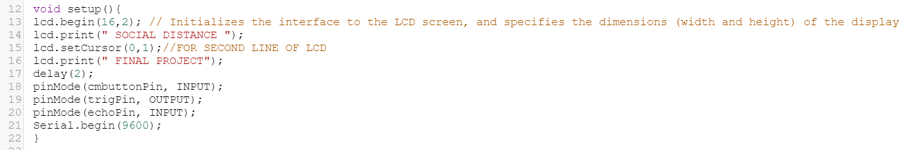

Figure 3.2

Line 12: this is for generate only once of my starts program.

Line 13: initializes the interface to the LCD screen, and specifies the width a d height of the display.

Line 14: print the character in LCD.

Line 18-20: declare all pin either execute became input or output.

1. 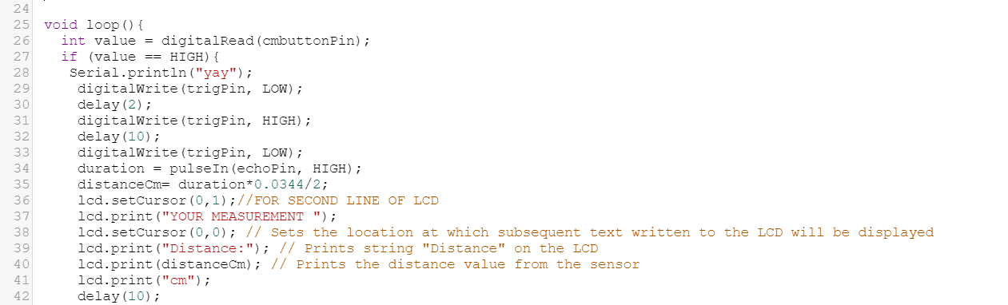

Figure 3.3

Line 25: This scope will implement all things with consecutively.

Line 26: Declare datatype for value or pushbutton pin.

Line 29-33: From figure 3.5, I also should set the pin to a LOW state for 2ms delay. For next, I should set the Trig pin to a HIGH state for 10 ms delay to initiate an Ultrasound wave

Line 34: Pulse will read either is a HIGH or LOW condition.

Line 35: Calculate the distance get from echoPin in centimeter unit.

Line 36-41: Using the reference on the Arduino website, the print() function will print anything based on what we write on the LCD. To write the code using the print() function. the result will be display in first line in LCD with centimeter unit while for second line will be show “YOUR MEASUREMENT”.

1. 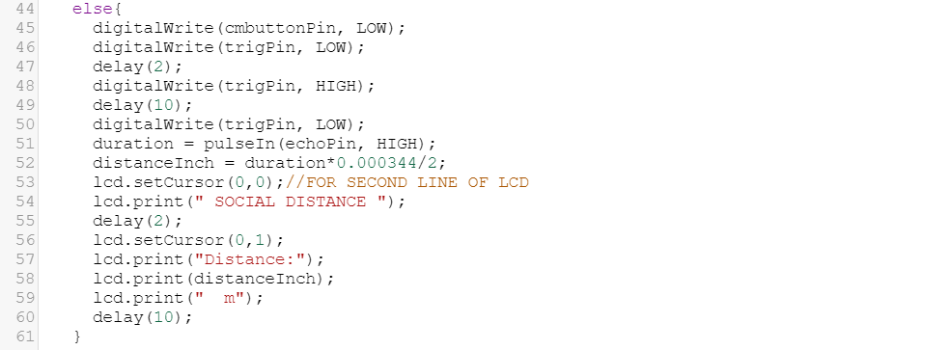

Figure 3.4

Line 45: Declare datatype for value or pushbutton pin.

Line 46-50: From figure 3.5, I also should set the pin to a LOW state for 2ms delay. For next, I should set the Trig pin to a HIGH state for 10 ms delay to initiate an Ultrasound wave

Line 51: Pulse will read either is a HIGH or LOW condition.

Line 52: Calculate the distance get from echoPin in meter unit.

Line 36-41: Using the reference on the Arduino website, the print() function will print anything based on what we write on the LCD. To write the code using the print() function. the result will be display in second line in LCD with meter unit while for first line will be show “SOCIAL DISTANCE”.

## 3.2 Flowchart

**LCD show**

**“WELCOME ATIQ**

**FINAL PROJECT”**

**Ultrasonic sensor sense object/obstacle**

**Pushbutton pressed?**

**First line show “SOCIAL DISTANCE” and convert input to centimetre and show at second line.**

**NO**

**YES**

**Second line show “YOUR MEASUREMENT” and convert input to metre and show at first line.**

Figure 3.5 Flowchart for Arduino Distance Measurement

## 3.3 Program Code

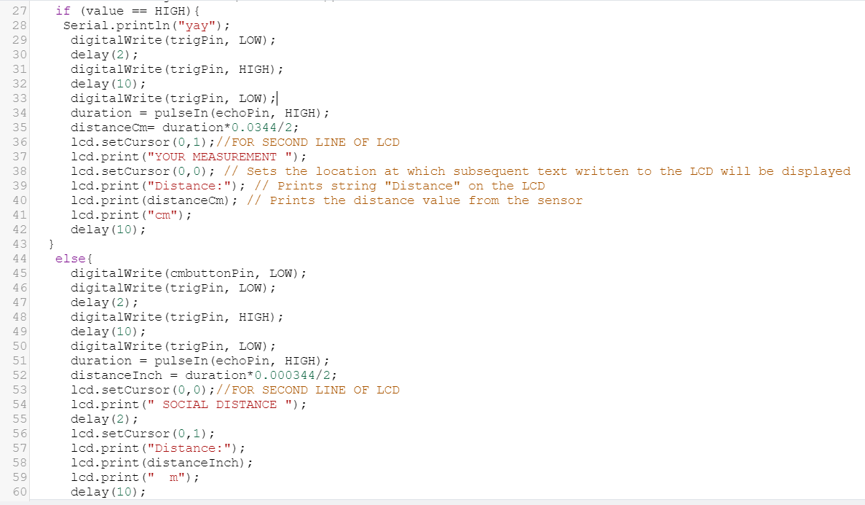

Figure 3.6 Program code for Arduino Distance Measurement

## 3.4 List of all component

Figure 3.11 table list of all component

|  |  |  |
| --- | --- | --- |
| Name | Quantity | Component |
| DISTdetector | 1 | Ultrasonic Distance Sensor |
| U2 | 1 | Arduino Uno R3 |
| U3 | 1 | LCD 16 x 2 |
| Breadboard | 1 | Breadboard Small |
| R4 R5 | 2 | 330 Ω Resistor |
| Sdisplay cm | 1 | Pushbutton |

## 3.5 Circuit Diagram

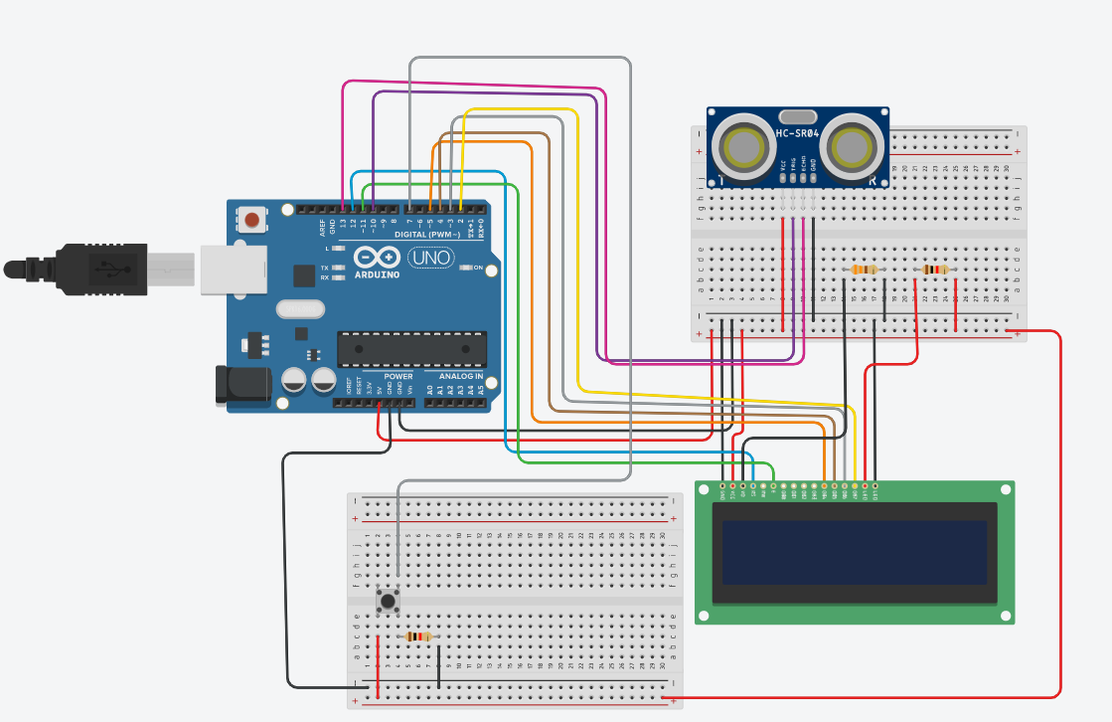

Figure 3.7 Schematic for Arduino Distance Measurement using Thinker CAD

# **Chapter 4**

## 4.1 Results and Discussions

### 4.1.1 Result

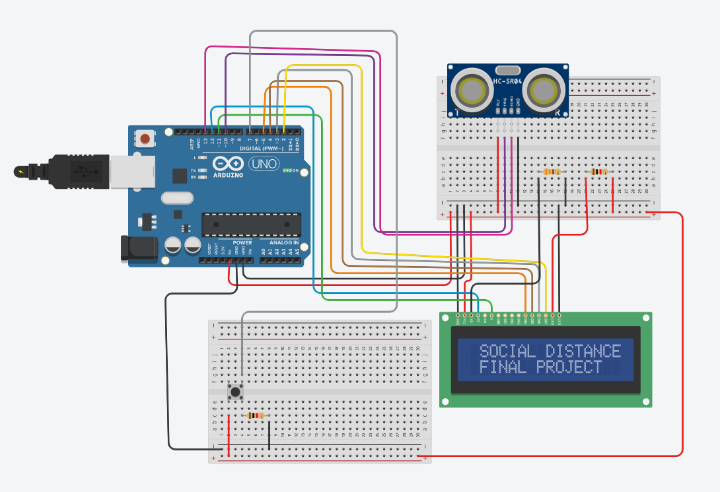

#### Figure 4.1.1 Initial condition when starting the program code

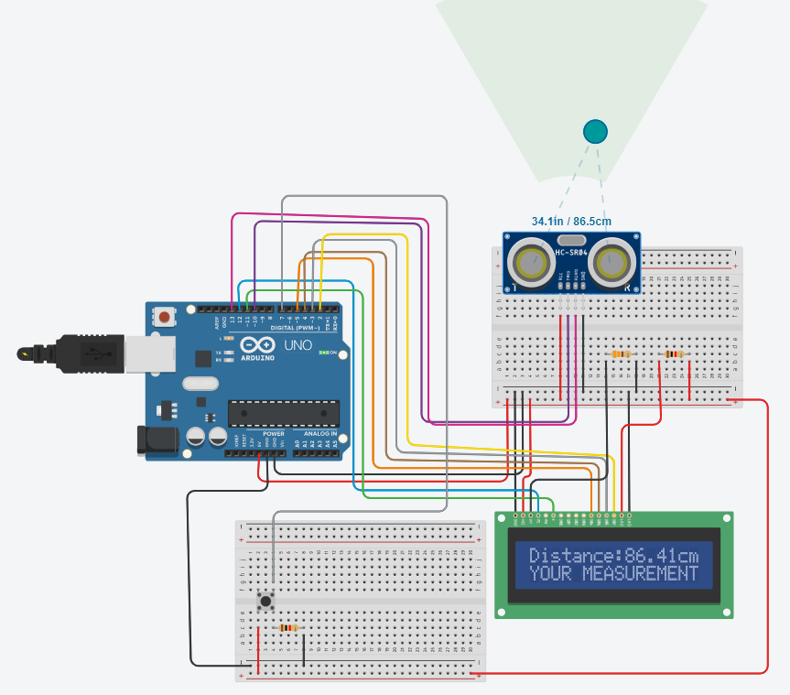

#### Figure 4.1.2 when pushbutton pressed

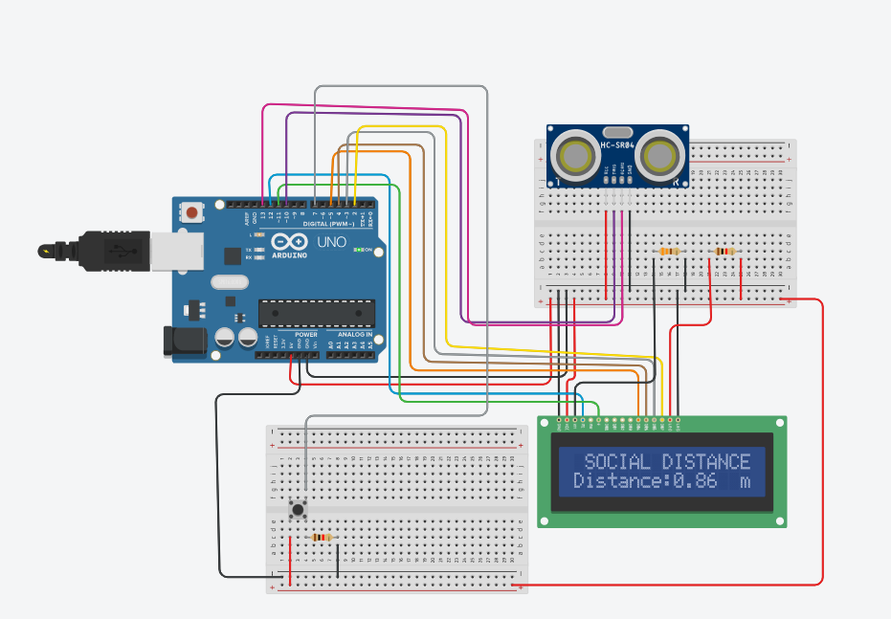

Figure 4.1.2 when pushbutton not pressed

### 4.1.2 Discussion

I have also had some challenges with the project as to when to calculate the echo and trigger. For the Echo pin on the Ultrasonic board, I need to calculate correctly to get the best value for centimeter and meter due to has absorbed an ultrasound of 40kHz that traveled the air, which might rebound to the module if there was an object or obstacle on its way [1]. Otherwise, I need to look at a lot of other research to know how to configure the trigger pin and echo pin in the Ultrasonic board.

The advantage of this project is that the affordable worth estimate below RM 45.00. After that, this product additionally straightforward to hold anyplace as well as for creating measurements within the slender place.

#### 4.1.3 Proposed budget

|  |  |  |  |  |  |
| --- | --- | --- | --- | --- | --- |
| No. | Name | Version | Price Per Unit | Reference | Cost |
| 1. | Ultrasonic Distance Sensor | HC-SR04 | RM 4.85 x 1 | Shoppe | RM 4.85 |
| 2. | Arduino Uno | REV3 | RM 18.00 x 1 | Shoppe | RM 18.00 |
| 3. | Cable Connector | 4 Pin Female to Grove 4 Pin Cable | RM 2.36 x 3 | Arduino Store | RM 7.08 |
| 4. | 16x2 LCD | LCD1602 Serial IIC I2C | RM 11.30 x 1 | Shoppe | RM 11.30 |
| 5. | Pushbutton  OMRON ELECTRONIC COMPONENTS B3F-1000 | B3F-1000 | RM 0.73 x 1 | Newark | RM 0.73 |
| Total  (RM) |  |  |  |  | RM 41.96 |

# **Chapter 5**

## 5.1 Conclusion

So what I've been doing with this project is measuring any object from ultrasonic sensor and ensuring that I will get at least a 1 meter for social distancing, and then being able to stop the spread of the COVID-19 pandemic, as the government suggests. Distance measurement using Arduino UNO and an ultrasonic sensor contains a rebound or echo pin for a high distribution frequency after collision with an object. Based on the collision, I will obtain the sound velocity and travel time to obtain the accuracy of the distance of an object.

This project can assist all sectors of industry or the market to ensure social distancing from human to human. For the measurement industry, this project minimizes the cost of purchasing a measurement tool because, according to my observation from the online platform, the price of measurement tools is very expensive compared to the Arduino UNO board.

From this project I learned to complete the Arduino code through the library. And then, I also learned to calculate the ultrasound sensor module HC-SR04 frequency which is to get the distance, I have to multiply the speed of sound with the travel time as I explain in chapter 3.

# References

|  |  |
| --- | --- |
| [1] | C. H. N. Soni, C. H. Sarita, S. Maheshwari, B. K Sahu, B. Jain, G. Shrivastava, "Distance Measurement using Ultrasonic Sensor and Arduino," *International Journal of Engineering Science and Computing,* vol. 7, no. 3, pp. 5991-5992, 2017. |
| [2] | Dejan, "Ultrasonic Sensor HC-SR04 and Arduino Tutorial," How To Mechatronics, 24 November 2015. [Online]. Available: https://howtomechatronics.com/tutorials/arduino/ultrasonic-sensor-hc-sr04/. [Accessed 10 December 2020]. |
| [3] | Jsvester, "Simple Arduino and HC-SR04 Example," Instructables, 27 May 2019. [Online]. Available: https://www.sparkfun.com/products/15569. [Accessed 8 December 2020]. |
| [4] | "ARDUINO UNO REV3," Arduino Store, 15 October 2019. [Online]. Available: https://store.arduino.cc/usa/arduino-uno-rev3. [Accessed December 9 2020]. |
| [5] | "Hello World!," Arduino.cc, 15 February 2018. [Online]. Available: https://www.arduino.cc/en/Tutorial/LibraryExamples/HelloWorld#see-also. [Accessed 8 December 2020]. |